CHANGE REQUEST FORM
Darvycom Australia Pty Ltd

This template provides a guide for you to complete the HUMAN RESOURCE MANAGEMENT PLAN
for the Darvycom Australia Pty Ltd project of cluster 6 of the ADIT TNE programme. Ensure you provide all relevant details for your final report before submission. Please refer to the project scenario of Tasks3 and 4 of Cluster 6 project for details regarding all aspects of this plan.

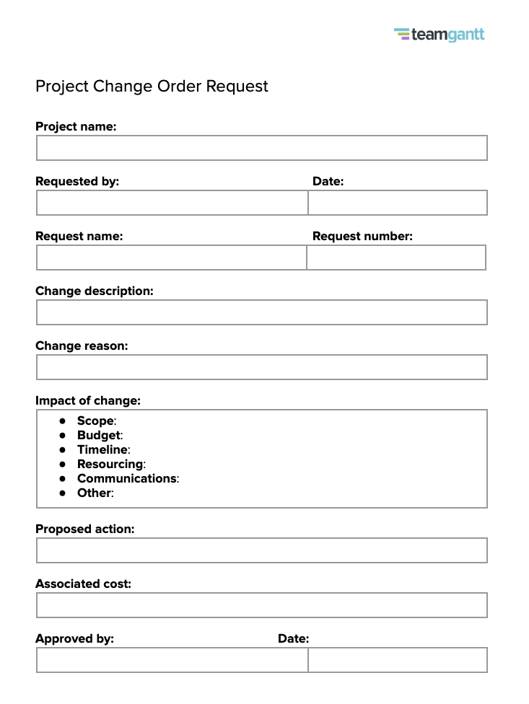
Project name
Darvycom Brisbane Engineering Laboratory Network and DSP Upgrade
Request by
Leonardo Matias Ciarcia – Project Manager
Request name
Staged pilot rollout for upgraded network and VoIP/DSP solution
Request number
CR-001
Change description
Current plan: a single cutover of the upgraded network, IP phones, voice server and DSP configuration across both Brisbane laboratory blocks during one implementation window.
Requested change:
- Introduce a staged rollout.
- Implement the full upgraded solution in Block A first as a controlled pilot.
- After Block A is confirmed stable and performing as expected, roll out the same solution to Block B.
- Add a dedicated pilot-testing day in each block before the new environment is considered fully operational.
The technical design, equipment list and target architecture remain the same; only the deployment approach and timing are adjusted.
Change reason
A staged pilot reduces operational risk during cutover. Deploying to one block first allows the team to identify and correct configuration or performance issues on a smaller scale, without disrupting all laboratory users at once. This is especially important because the project introduces a new IP-based voice platform and DSP configuration focused on improving call quality and signal-to-noise ratio. The change protects business continuity and reduces the risk of rework or extended outages.

Impact of change:
- Scope
No change to project deliverables. Additional activities are limited to pilot testing and minor documentation updates describing the staged rollout.
- Budget
Minor increase in labour cost due to extra pilot testing and coordination (estimated at approximately AUD 3,500). This can be covered by the existing project contingency, so the approved overall budget of AUD 200,000 does not change.
- Timeline
Expected extension of the implementation and testing phase by around one week to allow for Block A pilot, issue resolution if required, and Block B deployment. Exact dates will be confirmed in the updated schedule.
- Resourcing
No additional personnel required. Existing team members will spend extra time on testing and monitoring during the pilot periods. Workload will be managed by adjusting internal task sequencing.
- Communications
Communication plan will be updated to include:
  - Separate notices for Block A pilot, Block B rollout and any planned service interruptions.
  - Clear explanation to laboratory staff about the staged approach and what to expect in each block.
- Other
Reduced implementation risk and improved confidence in the final solution. The risk register will be updated to reflect lower cutover risk and to capture any new risks identified during the pilot.

Proposed action
Approve the staged rollout approach and update the Project Management Plan, Schedule Management Plan and Communication Management Plan to reflect:
- Block A as the initial pilot deployment site.
- A dedicated pilot-testing day for Block A before confirming stable operation.
- Subsequent rollout to Block B once Block A is signed off.
- Updated milestone dates and communication activities.
The project manager will coordinate detailed scheduling, assign tasks to the technical team and report pilot outcomes to the sponsor.
Associated cost
Approximate additional cost: AUD 3,500 in labour (pilot testing, monitoring, additional coordination).
This amount will be funded from the existing contingency allowance and does not increase the total approved project budget.
Approved by
Name: _______________________________
Role: Project Sponsor / Client Representative
Signature: ___________________________
Date
____ / ____ / ______

